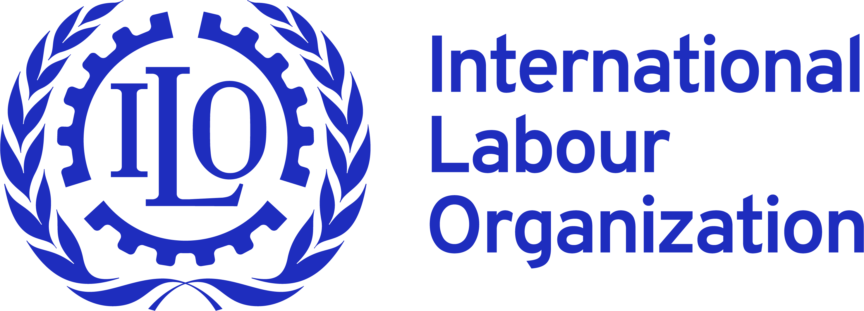

REQUEST FOR EXPRESSIONS OF INTEREST

May 2021

REQUEST FOR EXPRESSIONS OF INTEREST (EOI) – SUSTAINBILITY ROADMAP TO SUSTAIN THE IMPACT OF BETTER WORK VIETNAM PROGRAMME
Background
- Better Work is a partnership program between the International Labour Organization (ILO) and the International Finance Corporation (IFC), aimed at improving labour standards and competitiveness in the global garment industry.
- ILO/Better Work started operations in Vietnam in 2009. Better Work Vietnam (BWV) aims to influence wider industry behaviour and policymaking to improve working conditions and labour standards in Vietnam. It does this by translating its experiences, lessons learned and best practices at the factory level into effective advocacy messages, both for buyers and national partners such as the government. The programme is now active in approximately 400 factories in the North and South of Vietnam reaching more than 650,000 workers.
- At the factory level, Better Work delivers three main types of services:
- Enterprise assessments: measuring compliance with international labour standards and national labour law;
- Enterprise advisory: advisors work with factories to establish effective management-worker committees, develop improvement plans, and help facilitate improvement activities.
- Training and industry seminar services: designed to support the advisory process by offering practical guidance and in-depth knowledge on areas of improvement (e.g. labour law, compensation systems, occupational safety and health, workplace cooperation).

Further information on the programme may be found at https://betterwork.org/where-we-work/vietnam/

Procurement of consultancy service for Better Work Vietnam programme
- Through this Expression of Interest (EOI), Better Work Vietnam is open for EOI for the work with its national partners to develop the sustainability roadmap to sustain the impact of Better Work’s methodology and approach.
- This consultancy will support Better Work Vietnam’s efforts to work with its national partners to identify the operational model of Better Work Vietnam and develop the roadmap to sustain the impact of Better Work’s methodology and approach. More specifically, the objective is to develop a collective action approach to further improve and sustain compliance with labour standards in the Vietnamese apparel sector.
- The ILO/Better Work Vietnam invites eligible individual consultants or legal entities to indicate their interest in providing the consultancy services to deliver these tasks.
Scope of works and deliverables
- Scope of works:
- Desk review of documents to describe how the BWV sustainability approach with its partners fit within the countries overall trade and (economic and social) development agenda.
- Exercise to map out current mandates, roles and responsibilities of the tripartite constituents regarding compliance in the garment sector.
- Engage with relevant constituents and stakeholders. This includes the development of a process, development of a set of questions, followed by individual meetings with these partners to solicit ideas and feedback in reaching the vision for a sector with high levels of compliance.
- Develop Proposal(s) for Sustainability based on Stakeholder feedback.
- Validation Process for a collective action approach towards to Sustainability.

- Key deliverables
- Work plan for the assignment, spelling out deliverables, dates, activities and feedback moments
- A (visionary) description of how the sustainability agenda fits within the broader trade and development agenda of Vietnam
- A mapping of constituents mandate, roles, responsibilities and resources (HR and financial) for increased compliance (in the apparel) sector
- Proposal for engagement process
- Questionnaire to be used during individual meetings
- Report summarizing input from individual meetings
- Proposal for roadmap for sustainability (increased and sustained compliance)
- Process for validation of roadmap for sustainability
- Reporting summarizing outcomes of the workshop
- Final roadmap for sustainability

Eligibility and timeline
- The selected consultant/consulting firm should have:
- Understand economic, political, cultural, and business context in Vietnam, and able to communicate effectively with local Vietnamese stakeholders, particularly the tripartite partners in that context.
- Good understanding of the labour context in Vietnam
- Demonstrated strategic and analytical thinking capability
- Proven ability to consult detailed stakeholder consultations, and of integrating actors’ interests into organizational planning and reform strategies.
- Basic understanding about the garment and footwear industry and ILO/Better Work
- Previous experience developing sustainability plans for organizations is an advantage.
- Timeline: The work under this assignment shall be finished by 15 December 2021

- Interested consultants or companies shall contact Better Work Vietnam by 30 May 2021 at latest at vietnam@betterwork.org for further information regarding the proposal submission and selection process.

